## IT Solution Page

## IT Services

## We are committed to providing our client’s with the highest level of proactive, quality service tailored to their unique needs.

## 24x7 Tech Support

## Remote Computer Support to Solve All Your Technical Problems

## Operational 24 hours, 7 days a week, 365 days a year, Global helpdesk available to users and administrators for real time help and problem resolution

## Starting from 50 USD per incident unlimited hours per day.

## Desktop Management

## Cyrus IT operates a desktop Management service capable of managing over 2000 end – users around globally

Support and Service is a Segment of Cyrus Information Technologies (Pvt) Ltd. Expertise a Pioneer in Multi-vendor maintenance services and IT infrastructure management in Sri Lanka. Cyrus IT provides maintenance support for many mission critical applications and Hardware Solution which includes:

Availability services for Hardware and Software services

Direct Technical Engineer Support for Enterprise hardware and Support

Facility Management

IT Outsourcing

24/7 365 Days Support Services for Critical Customers

24x7 Global Tech support

## Manage services

Our Managed Services resource provides a full range of IT outsourcing for infrastructure, applications and ongoing user support. With their day-to-day contact with our clients, they are absolutely critical in building and sustaining good long-term relationships and in delivering essential operational intelligence.

Cyrus IT is able to provide a consistent support and Interface to its clients in Sri Lanka. The combined skill sets comprises several qualified and skilled engineers, technical consultants and experience Project Managers

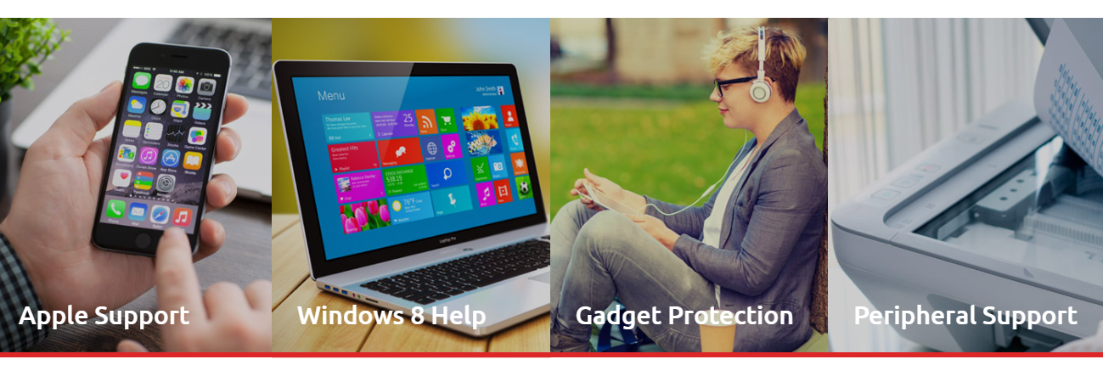

Desktop and End User support

Enterprise Support

Network support

AMC Support

Professional services

**Desktop and User manager service**

Outsourcing your end user support services to Cyrus IT will enable your business to transfer the operation and management of your desktop environment and processes to our highly qualified and trained technicians, leaving you free to concentrate on your core business and immediate priorities. We ensure that each end user has the right tools available to them to increase productivity and satisfaction levels.

With Cyrus IT managing your desktop environment, you will experience robust security for your data and infrastructure, allowing your IT staff to focus solely on delivering the technology solutions to meet company’s business objectives. Our knowledge and expertise encompasses managing multi-vendor desktop environments as well as our own end-user computing solutions. This is of high value to our clients as it gives them the peace of mind knowing that with Cyrus IT managing their desktop environment, they are truly safe in the hands of trained specialists.

## Starting from 50 USD per incident Un-limited hours per day. CONTACT US

**Enterprise Manage services**

Cyrus IT has significant experience configuring and managing server and storage infrastructure in large organizations, and has technical experts in server and storage networks. Cyrus IT is a Microsoft, VMware, EMC, Gate Protect, CISCO, and HP partner. In addition we constantly build on our already substantial experience with emerging and enterprise class technologies such as public, private and hybrid clouds, n-tier application architecture and virtualization technologies. Timely delivery, responsive operations control, infrastructure management and proactive activities such as capacity management Help ensure continued effectiveness and availability of our customers’ IT infrastructure.

## Starting from 500 USD for Enterprise support per month. CONTACT US

## Network Infrastructure support

We are a leading IT Managed Service Provider (MSP) serving the Srilanka and global market for SMBs. Our Network infrastructure support solutions are designed to help businesses embrace the technological advancements of today’s world and tomorrow’s world.

From Small medium organization to Enterprise organization Cyrus IT can tailor the solution to meet your own particular needs. For a single monthly price per seat, you will be free from the issues surrounding managing your Network environment and keeping pace with technological change, and give your users the service they need.

## Starting from 500 USD for Enterprise support per month. CONTACT US

## AMC Support

We at IT Solutions & Services professional Computer AMC Service provider in New Delhi, have expert and Certified Computer Software, hardware, networking and Server Engineer. Now you don’t need to worry about daily computer hardware, software, networking etc. issues. Our Engineers are able to understand and resolve all types of IT issues within the minimal time period and provide you satisfactory service to give you best IT AMC Service experience.

Maintenance and upkeep of hardware is one of the biggest opportunities in the Srilanka and global hardware market. Cyrus IT is superbly positioned to take advantage of the coming boom in the market for repair, maintenance and incremental replacement of computer hardware, parts and peripherals.

We offer Annual Maintenance Support (AMC) services with installation and commissioning as well as maintenance and critical services, as well as warranty Upgrade Packs

We under take the following brands and hardware

Dell, HP, Lenovo, Printers, and peripheral support

## CONTACT US

## Professional Services

“Our professional services help customers take back control of their IT systems. We ensure business continuity. WE DESIGN IT, INSTALL IT, UPDATE IT, Monitor it and MANAGES IT, so you can run your business”.

We offer project-based services including:

End-to-end deployment of Networking

Cyber Security & IT Infrastructure upgrade

Technology Migrations

Building Data Centre

O365 Migrations

AD Migrations

Domain Migrations

Server Migrations

Data center relocations

Product training and Educations

## CONTACT US

## 

We are committed to providing our client’s with the highest level of proactive, quality service tailored to their unique needs.

“...Managed services pro­vide affordable solutions to the complex technology problems of small businesses for a fixed monthly fee.”

**On Site Technicians**

Cyrus IT offers the option of having an onsite IT technician(s) that are highly trained and qualified to provide quality support and services. This will be a Cyrus IT employee and will be supported by the service desk team to ensure a premier support service at all times. Working hours and all other aspects will be agreed upon and included as part of the managed desktop support agreement. We will provide cover in the event of sickness and holiday, and take full employer and employee responsibility. All our Onsite Support engineers are highly qualified and trained to provide a fist class on-site support.

All our engineers are well certified by industry leading vendor certifications such as Microsoft, Dell, HP, CISCO, VMware, etc. Cyrus IT engineers are up to date qualified with latest technology and products.

**24 x 7 Tech Support TEAM**

Our technical staff are highly qualified and trained to provide a first class support to our customers. The Service Desk support team includes:

* Technical team who ensure all operational tasks are completed to maintain the systems.
* 3rd Line Support Team who specialize in the different technology areas providing a much deeper level of knowledge for troubleshooting.
* Security Management team who dedicates themselves to ensure a robust, safe and protected network whilst making certain that all security compliance and regulations are met. Their process is the foundation for all of the services Cyrus IT provides.